



What will I learn?

How to promote positive behaviour
How to support pupils in English, Maths, and ICT
How to promote children's social, emotional and physical development
How to safeguard children and young people
How to develop positive relationships

Teaching Assistant Level 2 Certificate



Qualification | Duration | Time | Age
City and Guilds | 28 weeks | 3 hours per week | 19+





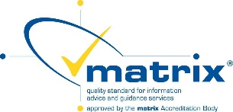
Important information about this course

If not already employed within the sector, you will be required to find a voluntary work placement within an appropriate school setting for a minimum 5 hours per week throughout the duration of the course.
You will be required to meet the requirements of an enhanced DBS.

Why study this course?
Learners who are 19+ and are thinking about becoming a teaching assistant or are interested in volunteering in schools. You may be entitled to a free course.
Achieve a nationally recognised qualification.
How do I enrol?
For further information or to book on this course please contact
Manygates Adult Education Centre:
- 01924 303302
- manygates@wakefield.gov.uk

